Notre Dame High School’s Social Injustices in our Modern World Reading Suggestions

Notre Dame invites you to examine and learn about social injustices in our modern world and how those injustices often lead to conflicts between people, society, cultures, races, and religions. Often the injustices that are written about in novels and works of non-fiction occur in the real world; they are difficult to read about and could make some readers uncomfortable. We have included information about the social issues addressed in the books on the reading list and a brief summary of the book. This will help our students make an informed choice and provide many different options. It is our hope that each of these books will foster discussions on the theme of justice and how we are called to respond as people of faith.

“But racism still profoundly affects our culture, and it has no place in the Christian heart. This evil causes great harm to its victims, and it corrupts the souls of those who harbor racist or prejudicial thoughts. As Christians, we are called to listen and know the stories of our brothers and sisters. We must create opportunities to hear, with open hearts, the tragic stories that are deeply imprinted on the lives of our brothers and sisters, if we are to be moved with empathy to promote justice. Many groups, such as the Irish, Italians, Mexicans, Puerto Ricans, Poles, Jews, Chinese, and Japanese, can attest to having been the target of racial and ethnic prejudice in this country. It is also true that many groups are still experiencing prejudice, including rising anti-Semitism, the discrimination many Hispanics face today, and anti-Muslim sentiment. Especially instructive at this moment, however, are the historical and contemporary experiences of Native and African Americans. By listening to one another’s experiences, we can come to understand and to empathize, which leads to those right relationships that unite us as brothers and sisters. This justice finds its source and strength in the love of Christ who laid down his life for his friends (see Jn 15:13). ” United States Catholic Bishops’ Pastoral Letter on Racism: Open Wide our Hearts, the Enduring Call to Love.” November 2018

For Grades 9 and 10
Students in grades 9 and 10 would benefit from reading any of the following books. This list is only for enrichment purposes and does not involve any summer assignment.

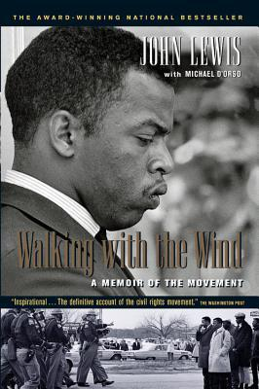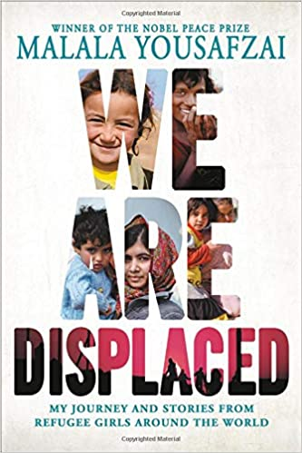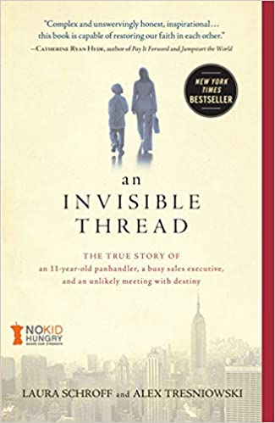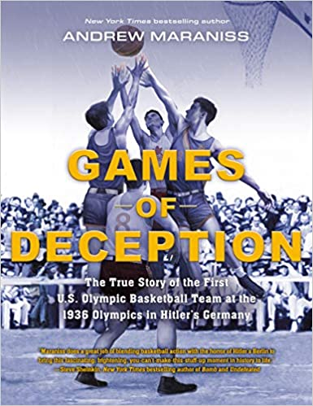

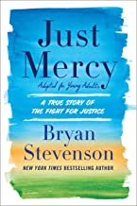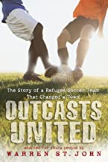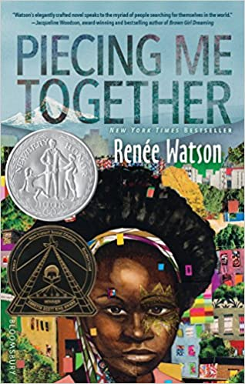

- Walking with the Wind: A Memoir of the Movement by John Lewis and Michael D’Orso
The son of an Alabama sharecropper, and now a sixth-term United States Congressman, John Lewis has led an extraordinary life, one that found him at the epicenter of the civil rights movement in the late '50s and '60s. As Chairman of the Student Nonviolent Coordinating Committee (SNCC), Lewis was arrested more than forty times and severely beaten on several occasions; he was one of the youngest yet most courageous leaders of the movement. Lewis takes us from the Nashville lunch counter sit-ins to the Edmund Pettus Bridge in Selma, Alabama, where he led more than five hundred marchers on what became known as "Bloody Sunday." (Winner of the 2015 Christopher Award, Robert F. Kennedy Book Award Grand Prize Winner, American Library Association Top of the List Award)
- We are Displaced by Malala Yousafzai
In her powerful new book, Nobel Peace Prize winner and New York Times-bestselling author Malala Yousafzai reminds us that every single one of the 68.5 million currently displaced is a person -- often a young person -- with hopes and dreams. Malala's experiences visiting refugee camps caused her to reconsider her own displacement -- first as an Internally Displaced Person when she was a young child in Pakistan, and then as an international activist who could travel anywhere in the world except to the home she loved. In We Are Displaced, which is part memoir, part communal storytelling, Malala not only explores her own story, but she also shares the personal stories of some of the incredible girls she has met on her journeys -- girls who have lost their community, relatives, and often the only world they've ever known.
- An Invisible Thread: The True Story of an 11-Year-Old Pandhandler, a Busy Sales Executive, and an Unlikely Meeting with Destiny by Laura Schroff (A 2019 Young Read’s Edition of this book is also available)

She was a successful ad sales rep in Manhattan. He was a homeless, eleven-year-old panhandler on the street. He asked for spare change; she kept walking. But then something stopped her in her tracks, and she went back. And she continued to go back, again and again. They met up nearly every week for years and built an unexpected, life-changing friendship that has today spanned almost three decades. The author writes, “Whatever made me notice him on that street corner so many years ago is clearly something that cannot be extinguished, no matter how relentless the forces aligned against it. Some may call it spirit. Some may call it heart. It drew me to him, as if we were bound by some invisible, unbreakable thread. And whatever it is, it binds us still.” (A Parents’ Choice Recommended Award Winner and
Junior Library Guild Gold Standard Selection)
- Games of Deception: The True Story of the First U.S. Olympic Basketball Team at the 1936 Olympics in Hitler’s Germany by Andrew Maraniss
1936 was a turbulent time in world history. Adolf Hitler had gained power in Germany three years earlier. Jewish people and political opponents of the Nazis were the targets of vicious mistreatment, yet were unaware of the horrors that awaited them in the coming years. But the 14 players of the first-ever U.S. Olympians on board the S.S. Manhattan and other international visitors wouldn't see any signs of trouble in Berlin. Streets were swept, storefronts were painted, and every German citizen greeted them with a smile. It was all just a facade, meant to distract from the terrible things happening behind the scenes.
(Winner of the 2020 AJL Sidney Taylor Honor; A 2020 ALA Notable Children's Book and
a 2020 CBC Notable Social Studies Book)

- Just Mercy: A True Story of the Fight for Justice (Adapted for Young Adults) by Bryan Stevenson
Bryan Stevenson delves deep into the broken U.S. justice system, detailing from his personal experience his many challenges and efforts as a lawyer and social advocate, especially on behalf of America's most rejected and marginalized people. The founder of the Equal Justice Initiative in Montgomery, Alabama, recounts his experiences as a lawyer working to assist those desperately in need, reflecting on his pursuit of the ideal of compassion in American justice. The book centers around his efforts to exonerate Walter McMillian, and innocent man who was condemned in Alabama and spent 6 years on death row. Last year, Just Mercy was made into an award-winning film starring Jamie Foxx and Michael B. Jordan and is currently available on Netflix. (Winner of the Carnegie Medal for Excellence in Nonfiction; Winner of the NAACP Image Award for Nonfiction; Winner of a Books for a Better Life Award; Finalist for the Los Angeles Times Book Prize; Finalist for the Kirkus Reviews Prize and An American Library Association Notable Book)

- Outcasts United: The Story of a Refugee Soccer Team That Changed a Town by Warren St. John

Luma Mufleh, a young Jordanian woman educated in the United States and working as a coach for private youth soccer teams in Atlanta, was out for a drive one day and ended up in Clarkston, Georgia, where she was amazed and delighted to see young boys, black and brown and white, some barefoot, playing soccer on every flat surface they could find. Luma decided to quit her job, move to Clarkston, and start a soccer team that would soon defy the odds. Despite challenges to locate a practice field, minimal funding for uniforms and equipment, and zero fans on the sidelines, the Fugees practiced hard and demonstrated a team spirit that drew admiration from referees and competitors alike. Outcasts United explores how the community changed with the influx of refugees and how the dedication of Lumah Mufleh and the entire Fugees soccer team inspired an entire community. (2013 Christopher Award Winner and 2013 Junior Library Selection)

- Piecing Me Together by Renee Watson
High school junior Jade is an "at-risk" student from a rough neighborhood in Portland, OR. She is also a talented collage artist, and she attends an elite private school on scholarship. More than anything, she wants to go on a study abroad week offered at her school to use her Spanish skills. Instead, she is given an invitation to join Woman to Woman, a mentorship program for young women like her: poor and black. Her mentor, Maxine, is from a more privileged background, and Jade doesn't see what she can learn from her. But in spite of her early resistance to Maxine, Jade begins to open up and gain confidence, and, eventually, she is able to express the importance of her family, her community, and her art. (NPR's Best Books of 2017; 2017 New York Public Library Best Teen Book of the Year; Chicago Public Library's Best Books of 2017; School Library Journal Best Book of 2017 and Kirkus Reviews' Best Teen Books of 2017)

For Grades 11 and 12
Students in grades 11 and 12 would benefit from reading any of the following books. This list is only for enrichment purposes and does not involve any summer assignment.

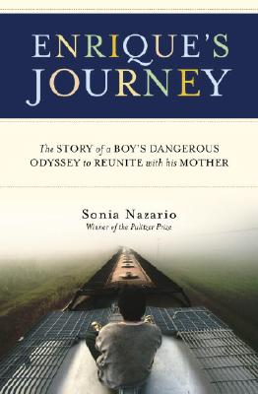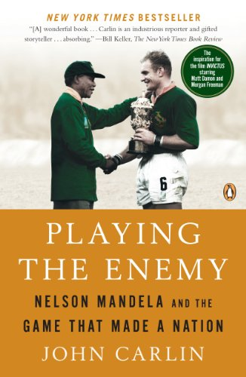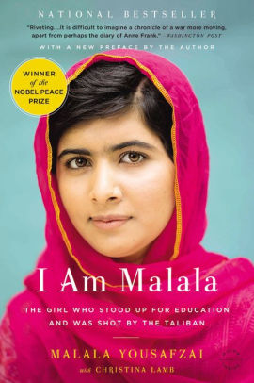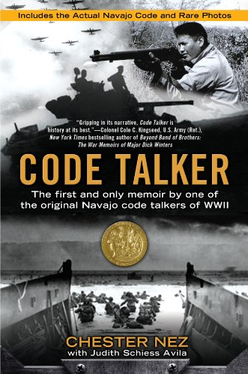

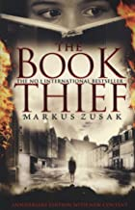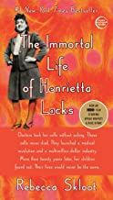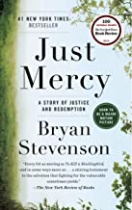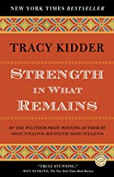

- Enrique’s Journey: The Story of a Boy’s Dangerous Odyssey to Reunite with his Mother by Sonia Nazario

Based on the Los Angeles Times newspaper series that won two Pulitzer Prizes, this page-turner about the power of family is a popular text in classrooms and a touchstone for communities across the country to engage in meaningful discussions about this essential American subject. Enrique’s Journey recounts the unforgettable quest of a Honduran boy looking for his mother, eleven years after she is forced to leave her starving family to find work in the United States. Braving unimaginable peril, often clinging to the sides and tops of freight trains, Enrique travels through hostile worlds full of thugs, bandits, and corrupt cops. But he pushes forward, relying on his wit, courage, hope, and the kindness of strangers.
(2006 Christopher Award Winner: California Book Award, Silver Medal, Non-fiction and 2003 Pulitzer Prize, feature writing, for “Enrique’s Journey.)

- Playing the Enemy: Nelson Mandela and the Game That Made a Nation by John Carlin

Beginning in a jail cell and ending in a rugby tournament- the true story of how the most inspiring charm offensive in history brought South Africa together. After being released from prison and winning South Africa's first free election, Nelson Mandela presided over a country still deeply divided by fifty years of apartheid. His plan was ambitious if not far-fetched: use the national rugby team, the Springboks-long an embodiment of white-supremacist rule-to embody and engage a new South Africa as they prepared to host the 1995 World Cup. The string of wins that followed not only defied the odds, but capped Mandela's miraculous effort to bring South Africans together again in a hard-won, enduring bond. (This book was the inspiration for the film, Invictus, starring Morgan Freeman and Matt Damon.)

- I am Malala by Malala Yousafzai with Christina Lamb
When the Taliban took control of the Swat Valley in Pakistan, one girl spoke out. Malala refused to be silent and fought for her right to an education. When she was 15, she was shot in the head a point-blank range while riding the bus home from school. Few expected her to survive. Instead, at 16 she became a global symbol of peaceful protest and used her passionate voice to inspire change in the world. Malala was the youngest recipient of the Nobel Peace Prize. Her book has been translated into more than 40 languages. (2013 Goodreads Choice Awards, Best Memoir & Autobiography, 2014 Political Book Awards, Finalist, Political Book of the Year.)
- Code Talker: The First and Only Memoir by One of the Original Code Talkers of World War II by Chester Nez
His name wasn’t Chester Nez. That was the English name he was assigned in kindergarten. And in boarding school at Fort Defiance, he was punished for speaking his native language, as the teachers sought to rid him of his culture and traditions. But discrimination didn’t stop Chester from answering the call to defend his country after Pearl Harbor, for the Navajo have always been warriors, and his upbringing on a New Mexico reservation gave him the strength—both physical and mental—to excel as a marine. During World War II, the Japanese had managed to crack every code the United States used. But when the Marines turned to its Navajo recruits to develop and implement a secret military language, they created the only unbroken code in modern warfare—and helped assure victory for the United States over Japan in the South Pacific. “Today, we marked a moment of shared history and shared victory. We recall a story that all Americans can celebrate and every American should know. It is a story of ancient people called to serve in a modern war. It is a story of one unbreakable oral code of the Second World War, messages travelling by field radio on Iwo Jima in the very language heard across the Colorado plateau centuries ago.” – President George W. Bush. (The author, Chester Nez, received the Congressional Gold Medal in 2001.)

- The Book Thief by Markus Zusak

When Death has a story to tell, you listen. It is 1939. Nazi Germany. The country is holding its breath. Death has never been busier, and will become busier still. Liesel Meminger is a foster girl living outside of Munich, who scratches out a meager existence for herself by stealing when she encounters something she can’t resist–books. With the help of her accordion-playing foster father, she learns to read and shares her stolen books with her neighbors during bombing raids as well as with the Jewish man hidden in her basement. “The kind of book that can be life-changing.” —The New York Times. “Deserves a place on the same shelf with The Diary of a Young Girl by Anne Frank.” —USA Today (2006: School Library Journal Best Book of the Year; 2006 National Jewish Book Award for Young Adult Literature; Michael L. Printz Honor Book- ALA Award that annually recognizes the "best book written for teens, based entirely on its literary merit and 2006 Publishers Weekly Best Book of the Year for Young Adult Literature.)

- The Immortal Life of Henrietta Lacks by Rebecca Skloot
Her name was Henrietta Lacks, but scientists know her as HeLa. She was a poor Southern tobacco farmer who worked the same land as her slave ancestors, yet her cells—taken without her knowledge—became one of the most important tools in medicine: The first “immortal” human cells grown in culture, which are still alive today, though she has been dead for more than sixty years. HeLa cells were vital for developing the polio vaccine; uncovered secrets of cancer, viruses, and the atom bomb’s effects; helped lead to important advances like in vitro fertilization, cloning, and gene mapping; and have been bought and sold by the billions. Yet Henrietta Lacks remains virtually unknown, buried in an unmarked grave.
Henrietta’s family did not learn of her “immortality” until more than twenty years after her death, when scientists investigating HeLa began using her husband and children in research without informed consent. And though the cells had launched a multimillion-dollar industry that sells human biological materials, her family never saw any of the profits. As Rebecca Skloot so brilliantly shows, the story of the Lacks family—past and present—is inextricably connected to the dark history of experimentation on African Americans, the birth of bioethics, and the legal battles over whether we control the stuff we are made of.
(National Academies Best Book of the Year Award, the American Association for the Advancement of Science's Young Adult Science Book award, and the Wellcome Trust Book Prize, awarded annually to an outstanding work of fiction or non-fiction on the theme of health and medicine. It also won the Heartland Prize for non-fiction, awarded to books that reinforce the values of heartland America.)

- Just Mercy: A Story of Justice and Redemption by Bryan Stevenson
Bryan Stevenson delves deep into the broken U.S. justice system, detailing from his personal experience his many challenges and efforts as a lawyer and social advocate, especially on behalf of America's most rejected and marginalized people. The founder of the Equal Justice Initiative in Montgomery, Alabama, recounts his experiences as a lawyer working to assist those desperately in need, reflecting on his pursuit of the ideal of compassion in American justice. The book centers around his efforts to exonerate Walter McMillian, and innocent man who was condemned in Alabama and spent 6 years on death row. Last year, Just Mercy was made into an award-winning film starring Jamie Foxx and Michael B. Jordan and is currently available on Netflix. (Winner of the Carnegie Medal for Excellence in Nonfiction; Winner of the NAACP Image Award for Nonfiction; Winner of a Books for a Better Life Award; Finalist for the Los Angeles Times Book Prize; Finalist for the Kirkus Reviews Prize and An American Library Association Notable Book.)

- Strength in What Remains by Tracy Kidder

Pulitzer Prize-winning author Tracy Kidder tells the story of one man’s inspiring American journey and of the ordinary people who helped him, providing brilliant testament to the power of second chances. Deo arrives in the United States from Burundi in search of a new life. Having survived a civil war and genocide, he lands at JFK airport with two hundred dollars, no English, and no contacts. He ekes out a precarious existence delivering groceries, living in Central Park, and learning English by reading dictionaries in bookstores. Then Deo begins to meet the strangers who will change his life, pointing him eventually in the direction of Columbia University, medical school, and a life devoted to healing. Kidder breaks new ground in telling this unforgettable story as he travels with Deo back over a turbulent life and shows us what it means to be fully human. (2010 Christopher Award Winner; Named one of the Best Books of the Year by Los Angeles Times • San Francisco Chronicle •Chicago Tribune • The Christian Science Monitor • Publishers Weekly.)

