Corporate Sponsorship at Notre Dame
Fall 2021/Winter 2022

With a six-decade tradition of excellence, Notre Dame High School’s Athletic Program is proud of its long and storied history of success and engages more than half of the school’s students each year.
The school boasts 28 Varsity sports for boys and girls and 55 total teams. Over the past several years, the school has won numerous league, county and state athletic championships. Notre Dame welcomes more than 10,000 fans to its sporting events each year.
Now, Notre Dame is providing local companies with marketing and advertising opportunities that support the Irish Nation! With a large social media following, Notre Dame can offer a range of incentives designed to give your local business added marketing exposure.

Current Offerings

Gold Level Stadium Advertising: $2,500:
- Sponsorship signage (2) in Nolan Stadium for the duration of the Fall 2021 or Spring 2022 season
- VIP stadium seating (6) at all home games and passes to the President’s Box. This package also includes pre and post event ND social media* coverage and inclusion on ND’s Corporate Sponsorship website
- Livestream TV advertising will be available during ND’s Varsity Football season through a partnership with WBCB

Patron Level Stadium Advertising: $750:
- Sponsorship signage (1) in Nolan Stadium for the duration of the Fall 2021 or Spring 2022 season
- Inclusion on ND’s Corporate Sponsorship website

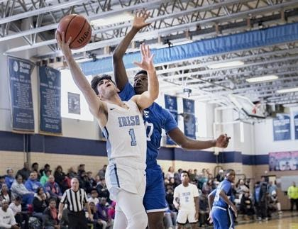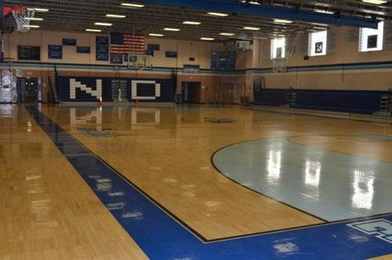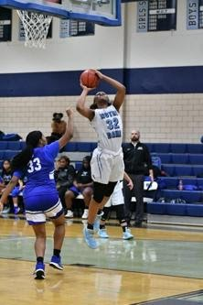

Winter 2022 Gymnasium Advertising:

Gold Level: $2500
- Primary Sponsor of the Varsity girls or boys basketball seasons, includes:
- Sponsorship signage for the duration of the Winter 2022 season
- VIP seating at all home games
- Pre and post event ND social media* coverage and inclusion on ND’s Corporate Sponsorship website
- Livestream TV advertising will be available during ND’s Varsity boys and girls basketball seasons through a partnership with WBCB

Patron Level Stadium Advertising: $750
- Sponsorship signage (1) for the duration of the Winter 2022
- Inclusion on ND’s Corporate Sponsorship website

*About Notre Dame Social Media

- Notre Dame Facebook - ND Facebook ads have a reach of 29,000 views per day with more than 6,000 followers. Posts will run one day before each game and on game day
- Notre Dame Tweets the day before and day of each game, attracting 1800 followers
- Notre Dame Instagram Posts the day before and day of each game attracting 4,000 followers
- Notre Dame website – your name displayed for the remainder of the season
- Custom Gameday Snapchat geofilters will be available

Many thanks to our recent Corporate Sponsors:

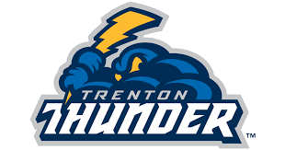 2021 Varsity Baseball

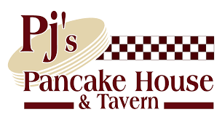
2020-2021 Varsity Boys Basketball

